***Guide to CTE Local Application System 2024-2026***

February 2024

Table of Contents

General Overview & Information 2

Part I: Comprehensive Needs Assessment (CLNA) 9

Part II: Data/Indicators of Performance 12

Part III: Local Application Narratives 14

Part IV: Application for Workstudy Program 17

Part V – 1: Perkins Federal Grant (PRC017) 17

Part V – 2: Months of Employment Grant (PRC 013) 18

Part V – 3: State Support Grant (PRC 014) 20

Part VI: Assurances and Certifications & Signature Page Upload 22

Grant Award Notification (GAN) 25

To Complete Application and Send to RC for Review… 26

CTE Local Application Checklist/NCDPI Feedback 27

Additional Information 28

# General Overview & Information

The CTE Local Application System has been developed in compliance *with Perkins V – The Strengthening Career and Technical Education for the 21st Century Act*. The Local Application serves as a district’s planning document and application for CTE state/federal funding. The completion and approval of the Local Application also serves as a compliance document which meets all requirements of Perkins.

The Local Application is a **two-year plan**. In year one the Comprehensive Local Needs Assessment is completed and strategies to address the identified needs are developed. In **year** **two strategies are reviewed and revised as needed.** Sections V & VI are completed annually. These sections include new budget information, assurances/certifications, and signature page. Please utilize the instructions in this document to complete the Fiscal Year 2025 Local Application.

**Part I-CLNA & Part II-Indicators of Performance**

**Due Date: March 15, 2024**

**Parts III – Part VI**

**Due Date: May 15, 2024**

(The signature page, is due soon after May 15, but no later than June 28, 2024)

URL: <https://ccip.schools.nc.gov/>

**ROLES AND PERMISSIONS**



**Layout of Main Page**

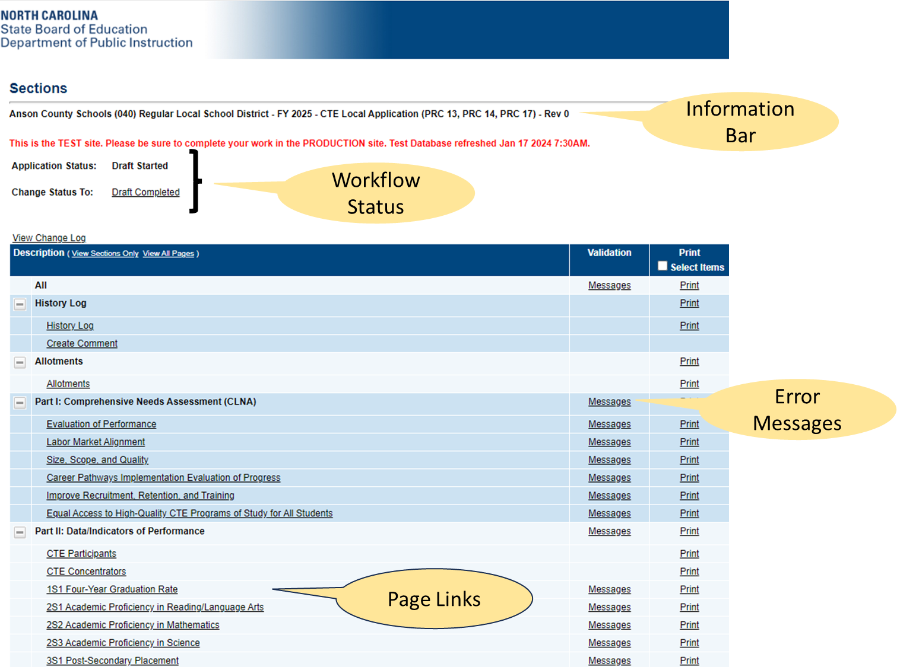

**Workflow Status**

* *Not Started* – **not editable**
* *Draft Started* – **fully editable**
* *Draft Completed* – application complete and ready for RC review
* *Revision Started* – application has been approved, but is now editable for revision
* *NCDPI CTE Local Application Regional Coordinator Approved*– **not editable**, status must be changed to Revision Started to edit.
* *NCDPI CTE Local Application Regional Coordinator Returned Not Approved* – **editable** for updates/changes requested by RC

***UPDATING USER PROFILE***

* Click on username

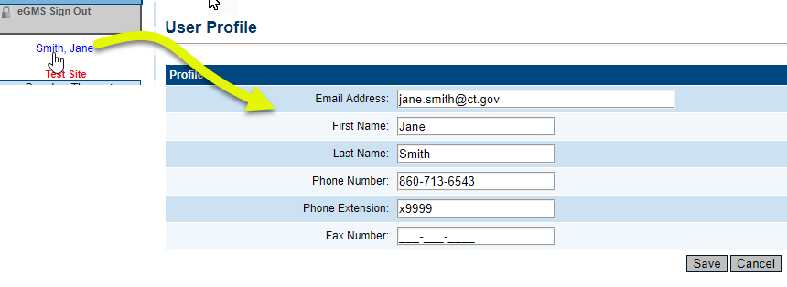

**MENU**

* *Inbox*– Record of system emails
* *Funding*– Access to grant applications
* *LEA Document Library***-** Upload district specific documents
* *Address Book*– list of users with LEA and SEA roles
* *Document Library*– Library of training, program guidance, forms
* *Contact NCDPI*– Submit Feedback form

**ADDRESS BOOK**

**SAVE AND GO TO BUTTONS**

* Use “Go To” and “Save and Go To” menus to navigate and to save your work
* “Save and Go To” saves any entered data
* “Go To” appears on pages that are not able to be edited
* Each selection of “Save and Go To” or “Go To” refreshes 60-minute session clock
* Current Page: Saves changes to the page and keeps user on that page
* 10-minute warning before end of session
* **Data will be lost if Save and Go To button is not used within 60 minutes**

**HISTORY LOG**

The History Log displays all status changes and Comments related to a funding application

**COMMENTS**

* Comments are ongoing notes and discussion related to a funding application
* Comments can be made by anyone with access to the application at any time, regardless of status
* Can be emailed to intended recipients

* Comments are saved within the funding application but not visible to public users
* Any messages generated from within NCCCIP system (notifications, bulk email, etc.) will have this sender address of  [NCCCIP.NoReply@eGrantsManagement.com](mailto:NCCCIP.NoReply@eGrantsManagement.com). See the example below.

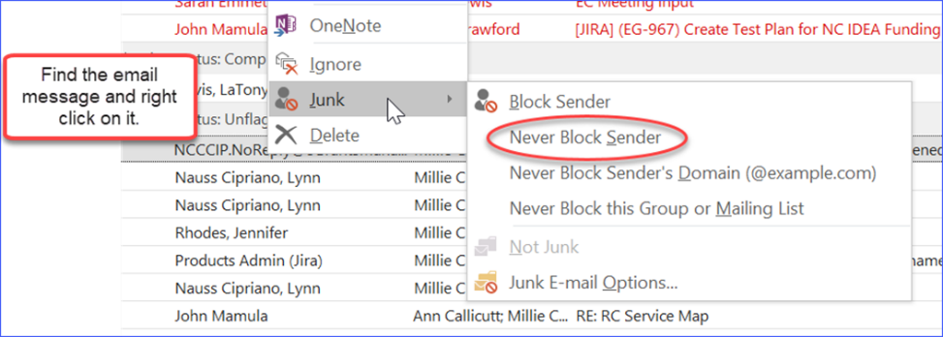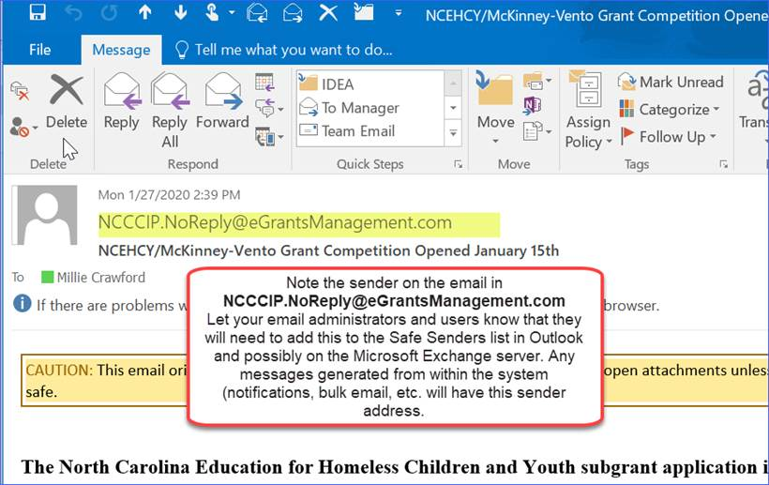

* Let your email administrators and users know that they will need to add this to the Safe Senders list in email and possibly on the local email server. See the instructional graphic for users attached.

**Getting Started**

* Sign in to CCIP using your unique NCID and NCID password

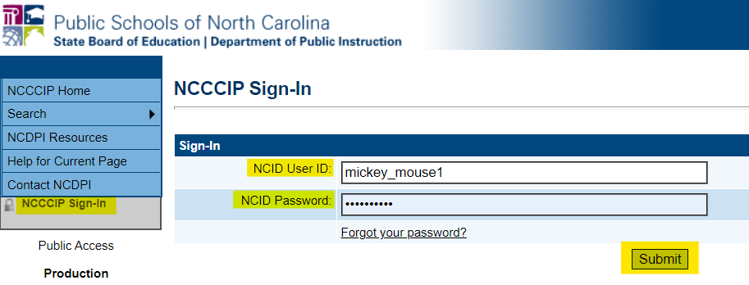

* Select district

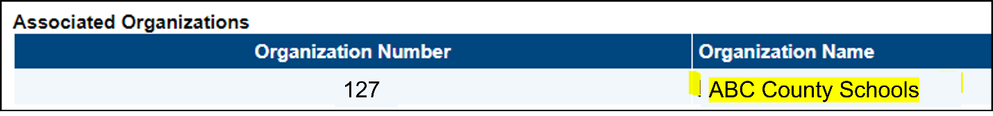

* Select application year **2025.**

* Select Funding Application: CTE Local Application

* Change Status To: Draft Started

* + You must click on “**Draft Started**” )

* Confirm

# Part I: Comprehensive Needs Assessment (CLNA)

Ratings for the current CTE Local Application Period 2024-2026 must be entered for ALL areas of the CLNA.

Evaluation of Performance has two boxes that require responses.

* Consultation Method
  + Identify which stakeholders were involved, the feedback method used, and how the CTE Leadership Team used this information to determine the ratings, identify needs, and develop improvement strategies.)
  + A white and black text on a white background

    Description automatically generated
* Identified Needs
  + Use the ratings and other feedback to identify areas of need. The CTE Leadership Team will determine the specific needs to be addressed. List the identified needs.
  + A white background with black text

    Description automatically generated

All other CLNA sections have four boxes, three of which, require responses from the PSU upon completion of CLNA. They included:

* Consultation Method
* Identified Need
* Describe how the identified needs will be addressed using the format below:
  + After needs have been identified within a particular CLNA section, the CTE Director and the CTE Leadership Team will identify at least one need per section to address during the next two-year period and will write strategies to address the need(s.) Strategies are then broken down into action steps.
  + Effective strategies include detailed information in the following areas: What, Why, How, Who, and When.
    - What - What are the real results we want to achieve?
    - Why - Why do we want to achieve these results? What are the benefits to the stakeholders?
    - How - How can we best achieve these results? What are the key strategies to achieve success?
    - Who - Who will be responsible for achieving each step?
    - When - When will each step take place and what will be the deadline to store the artifact?
  + You can use the following Effective Strategy Template or detailed bulleted list inclusive of all requirements.
  + A screenshot of a computer

    Description automatically generated

The fourth textbox included is to allow Regional Coordinators to provide feedback to PSUs.

* NCDPI Feedback
  + Upon review the PSUs response, the Regional Coordinator will provide appropriate feedback to the CTE Director regarding the information that has been submitted.
  + A screenshot of a computer

    Description automatically generated

# Part II: Data/Indicators of Performance

The first two pages (CTE Participants & CTE Concentrators) are informational and do not require PSU/LEA responses. The remaining pages provide data and require responses. Respond to the following prompt in each Performance Indicator

***Describe how your CTE program will address No Meaningful Progress in overall performance and the disparities or gaps in student performance.***

**What is Meaningful Progress and what do I do if meaningful progress is not met?**

Use the guidelines below for each Indicator of Performance to determine if you district has met “Meaningful Progress”.

* Meaningful progress means that you met 90% of **overall** local benchmark for at least one of the previous two consecutive years.
* If you did not meet 90% of **overall** local benchmark for both of the previous two consecutive years then you “did not” meet meaningful progress.

Check the appropriate box under each Indicator of Performance based on the above guidelines.

A specific strategy must be identified for each Indicator of Performance that is identified as “Did not meet” Meaningful Progress.

If an Indicator of Performance is identified as “having not met Meaningful Progress”, a strategy to improve the indicator must be added or an existing strategy that targets the deficiency must be highlighted. Contact your Regional Coordinator for more specific instructions.

Please use the following guidance when writing responses to address “**No Meaningful Progress**” for overall performance or gaps in student performance for specific subgroups.

* Identify “What” gap you will be addressing.
* Indicate “Why” you are addressing these gaps. (having not met… )
* Provide the “Strategy” you plan to use to address the gaps.
* List the “Action Steps” you will use to implement the “Strategy”
  + For each “Action Step” include “Who” will be performing the action and “When” it will be performed.
* **Use the Effective Strategy Template**
  + A screenshot of a computer

    Description automatically generated

**Or**

* **Use this Example** (2S2 Academic Proficiency in Mathematics has not met meaningful progress)
  + Identify: 2S2 Math
  + Why: Math has not met meaningful progress.
  + Strategy: All CTE students, will have increased emphasis of math integration into CTE Curriculum.
  + Action Steps:
    - Each action steps should include the action, who is responsible and when the action will take place.

# Part III: Local Application Narratives

The Local Application Narratives Subsection included three parts. The first pertains to Career Pathways offered in your district, the second pertains to CTE Local Courses and the last part includes 6 narrative prompts.

**State Approved Career Pathways**

List all state-approved career pathways offered in your district by using the drop-down box. The pathways are grouped alphabetically by the career clusters in the table below. Typing the first two or three letters of the career cluster in the drop-down list will move the list to that career cluster list of pathways. Select Add Row to add additional pathways. These selections will carry forward for future applications.

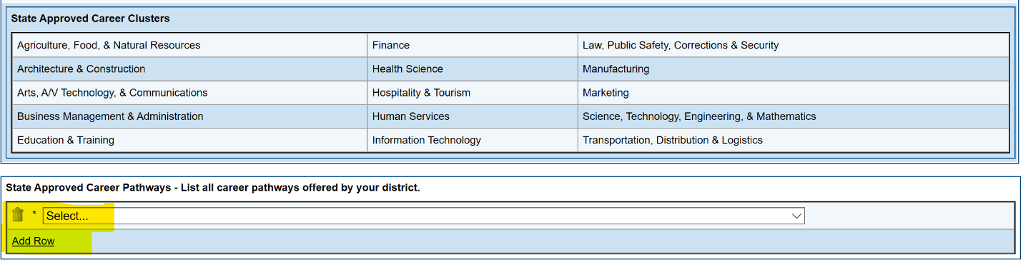

**CTE Local Courses**

Select the appropriate radio button to indicate whether your district is offering CTE Local Course Options (LCO). If you select that your district is offering approved CTE LCOs, list those LCOs that are being offered.

**Narratives**

There are six prompts that require responses. Be certain that the responses are thoughtful, specific, and descriptive.

**Prompt #1a:**

The first section in prompt one deals specifically with funding. “Describe how the results of the comprehensive local needs assessment informed the selection of the specific CTE programs and activities selected to be funded.” Specifically describe how purchases of items and services from PRC 017 will meet the needs, strategies and actions steps identified in the CLNA. Also be sure that these purchases are evident in Part V-1 Perkins Federal Grant (PRC 017).

Response formatting is at the discretion of the district. Please address the prompts in a way that is most beneficial in guiding the work that will occur in the district over the next two years. Below are two examples from existing applications. The Regional Coordinator for your area is available to assist you with the process.

**EXAMPLE #1**

The comprehensive local needs assessment solidified ABC County Schools’ current CTE programs and identified career pathways that need to be added or expanded using Perkins funding.

The needs assessment included representatives from all stakeholders who gave feedback on the current and future labor market needs of the area and regional business/industry partners.   These conversations and reviews are vital to ensure that our programs meet current and future employer needs creating talent pipelines.

|  |  |  |  |  |
| --- | --- | --- | --- | --- |
| **Strategy 1): Identify CLNA informed programs and corresponding activities where Perkins funding will be used.** | | | | |
| **Methods and Action Steps** | **Fiscal Year** | **Responsible Parties and Participants** | **CLNA Category** | **Location** |
| Purchase equipment and supplies for a new Electrical program. | 2024-25 | CTE Director, CIMC, Teacher | Labor Market | XYZ High School, Electronics Lab |
| Purchase supplies, equipment, software and credentials to update and maintain the following existing high wage, high skill, and in demand pathways: All Agriculture, Business and Marketing, Family and Consumer Science, Trade, Industrial and Technology, and Health Science Pathways. | 2024-25, 2025-26 | CTE Director, CIMC, Teachers, Administrative Assistant | Labor Market | RST High School, XYZ High School, KLM Middle School |
| Purchase Press Brakes for welding and fabrication program to support advanced manufacturing pathway. | 2025-26 | CTE Director, CIMC, Teacher | Labor Market | RST High School |
| Purchase supplies, computer equipment, software, and credentials for new Adobe Academy Pathway. | 2024-25, 2025-26 | CTE Director, CIMC, Teachers | Labor Market, Student Credentialing Quality | RST High School, Adobe Lab |
| Provide Career Development and CTSO Field Trips for students in all program areas and academies. | 2024-25, 2025-26 | CTE Director, CDC, Teachers | Size, Scope and Quality | All MS & HS |
| Provide needed staff development for teachers in all program areas and CDC/SPCs to meet program goals and objectives. | 2024-25, 2025-26 | CTE Director, CIMC | Recruitment, Retention and Training of CTE Educators | Central Office and all MS & HS |

**Prompt #1b:**

Provide a detailed responses to prompt 1b:



**Prompt #2 - 6**:

Provide detailed responses to prompts 2-6 being sure to address each part of the prompt. Prompts two and three have multiple sections.

**Prompt #7**:

The details of this prompt are addressed in Part II of the Local Application. Because of the way the legislation is written it also needs to be addressed in Part III. The response below is appropriate for all districts and can be copied into the textbox for this section without editing.

*Part II of this local application describes the improvement process that will take place over the next two years. Local benchmarks for the current year and future years have been identified and performance data will serve as our indicators of success. To improve the academic and technical skills of our students, our CTE program will specifically focus on the improvement of academic proficiency in Reading/Language Arts, Math, and Science. Our technical skills improvement efforts will focus on two performance quality measures including the increase of student industry recognized credential attainment and improved student performance on state assessments and Performance Based Measures. In addition, students are provided guidance to participate in career awareness and development opportunities while following a Career Pathway of their choice (see Career Pathways offered in this section). Career Pathways provide students the opportunity to participate in academic and technical courses while becoming a CTE concentrator. Students also have the opportunity to accelerate their learning through articulation credit and opportunities to participate in Career and College Promise coursework.*

# Part IV: Application for Workstudy Program

If the district plans to offer Workstudy for Fiscal Year 2025 please complete this application. If Workstudy is not being offered, no action is needed.

# Part V – 1: Perkins Federal Grant (PRC017)

Utilizing the Fiscal Year 2025 PRC 017 planning allotment, enter the budget into LBAAS (Local Budget and Amendment System). In most districts the Finance Department is responsible for the LBAAS entry. LBAAS feeds directly into CCIP so that budget information by line item is visible in Part V Section 1 of the Local Application. ***All entries for this section occur in LBAAS.***

Detailed information is required for the following object codes: ​

* 461 – Furniture & Equipment – Inventoried​
* 462 – Computer Equipment - Inventoried​
* 541 – Equipment Purchase – Capitalized​
* 542 – Computer Hardware Purchase - Capitalized​

For these object codes you must include: quantity, per unit designation, a detailed description, program area and location (match with Part III Narratives Prompt 1) **The PRC 017 budget will not be approved if this information is not provided.** See example below.

|  |  |  |  |  |  |
| --- | --- | --- | --- | --- | --- |
| Quantity | Unit Cost | Equipment Amount | Description | Program Area | Location |
| 1 | $4,324.25 | $4,324.25 | Press Brakes | T&I | RST High School, Automotive Shop |
| 4 | $3,225.20 | $12,900.80 | Electrical Trainer | T&I | XYZ High School, Electrical Trades Lab |

# **Part V – 2: Months of Employment Grant (PRC 013**)

PRC 013 requires an uploaded Personnel Assignment Plan in ***spreadsheet format*** for the months of employment provided through PRC 013 and all salary fund sources. Utilize the Fiscal Year 2025 PRC 013 Planning Allotment.

The **Personnel Assignment Plan** spreadsheet should include the following data: PSU/LEA, school name, teacher’s name and program area, support personnel’s name and support area, fund source of MOEs (i.e. PRC 014, PRC 017, ADM, Local, Other) and total MOEs allotted and used. The budget must include all allotted months of employment. (If your Personnel Assignment Plan includes remaining Months of Employment, you are expected to include an explanation on how those remaining months will be converted and used.)

***Sample Spreadsheet***



The upload occurs in Part V – 2 Months of Employment Grant (PRC 013) – see screenshots below.

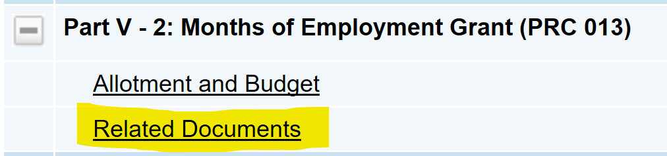

*Document name is not a required field; the filename will be retained if a document name is not entered.

# Part V – 3: State Support Grant (PRC 014)

Utilize the Fiscal Year 2025 PRC 014 Planning Allotment and enter the budget directly into the CCIP Local Application System. The columns indicate the budget purpose codes and the rows represent the object codes. The amount allocated for each line item should be entered in the appropriate cell. The last three rows automatically calculate the object code totals, adjusted allocation and any remaining amount that is unbudgeted. Once the budget entry is complete the remaining amount ***must*** be zero (0.00).

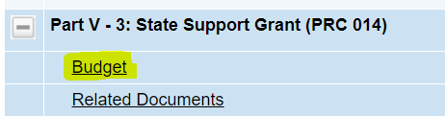

Notice the following features that are available for your convenience:



* Download Budget Data: Downloads the budget to an Excel format
* Collapse/Expand Budget:

Collapse (Displays the total per object code category) 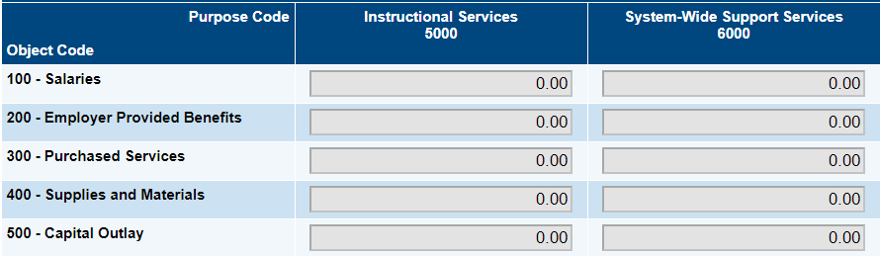

Expand (Displays the object code detail) 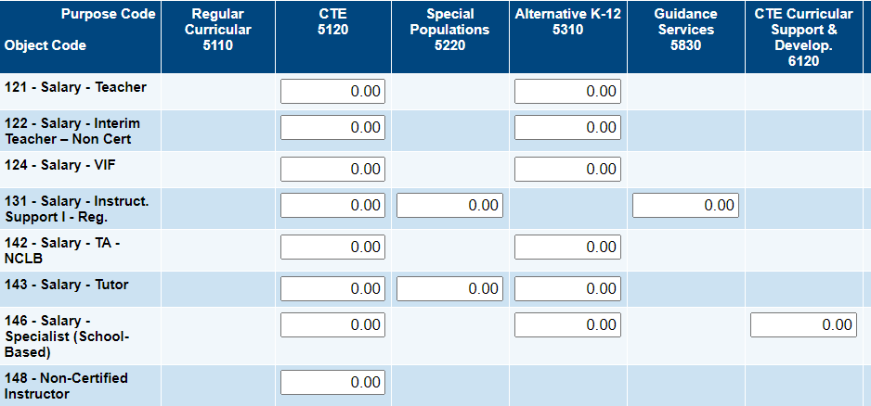

* Hide Unbudgeted Categories: Hides line items with a zero balance and displays only object code with a budgeted value.

# Part VI: Assurances and Certifications & Signature Page Upload

Carefully review all three pages in this section:

* Assurances
* Debarment Assurance
* Certification Regarding Lobbying for Grants and Cooperative Agreements

Make sure the Superintendent and the local Board of Education understand the contents of the Assurances and Certifications. This Application is a necessary part of the State Board of Education’s accountability to the General Assembly of North Carolina and the U.S. Department of Education. These assurances signal the local educational agency’s capacity to carry out the State and Federal legal requirements and policies during the timeframe of this local plan.

Check the box for each page certifying that “The LEA hereby assures the SEA (State Education Agency) that…” and “The undersigned certifies, to the best of his or her knowledge and belief, that...”

Additionally, a physical signature page containing the following signatures must be uploaded prior to final approval of the application:

* Superintendent
* Board of Education Chairperson
* Finance Officer
* Director, Career and Technical Education

**The signature page** is to be downloaded from the “LEA Document Library.” See screenshots below.

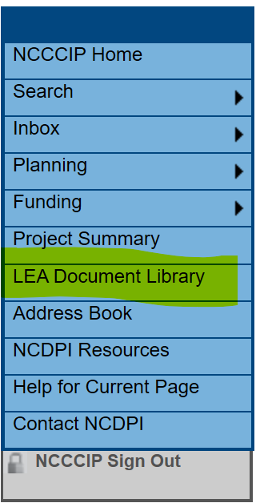

Once the document has been downloaded, signatures should be secured. Once the document has all required signatures and dates, scan the document and upload to the “LEA Document Library.” See screenshots below. Establish a local audit file for your PSU/LEA, including a copy of the signed signature page and a copy of the Board minutes/agenda reflecting the local approval of the application.

***MUST BE UPLOADED with signatures BY JUNE 28, 2024***

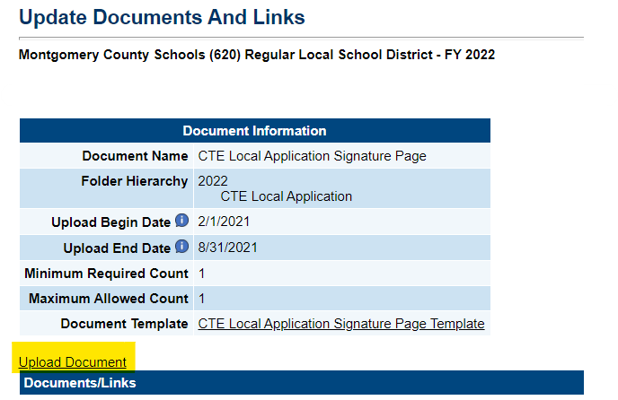

*Document name and Document Description are not required fields; the filename will be retained if a document name/description is not entered.

# Grant Award Notification (GAN)

**GAN Information**

Upon final approval of your Federal Grant applications and budgets within the Comprehensive Continuous Improvement Plan (CCIP) Grants Management System, your Grant Award Notification will populate for the programs that have received approval. The amounts listed are **estimated amounts**; the final award amount will be made available at [NCDPI School Allotment Section](http://apps.schools.nc.gov/ords/f?p=144:1). The estimated award amount can be found within the allotments section of your organization's CCIP application and within the local budgeting system. Once the Grant Award Notification is populated within CCIP, the memorandum will provide the authority to request, receive, and expend these funds. Your organization will receive notification from the DPI Allotment System when the funds approved through populated Grant Award Notification are available for drawdown.

**GAN Organization Data**

The GAN Organization Data sections highlighted below must be completed.

* Unique Entity Identifier (UEI) : The UEI is an alphanumeric sequence that you should be able to obtain from your finance office.
* Address: Please enter the mailing address for the district
* Superintendent: Please enter the name of the district superintendent
* Key Personnel: Please enter the name of the CTE Director & any other personnel deemed “key” in the development of the CTE Application ex. Jane Doe, CTE Director

# To Complete Application and Send to RC for Review…

Prior to completing the draft and sending the application to RC for review, utilize the Validation Message to determine errors or warnings in the application. Messages are allowable in PRC 017 only; any other messages must be addressed prior to completion.

Once the application status is changed to “Draft Complete,” the application cannot be edited by the Director until the RC approves the plan or returns it for revisions.

Sections or pages can be printed from the landing page.

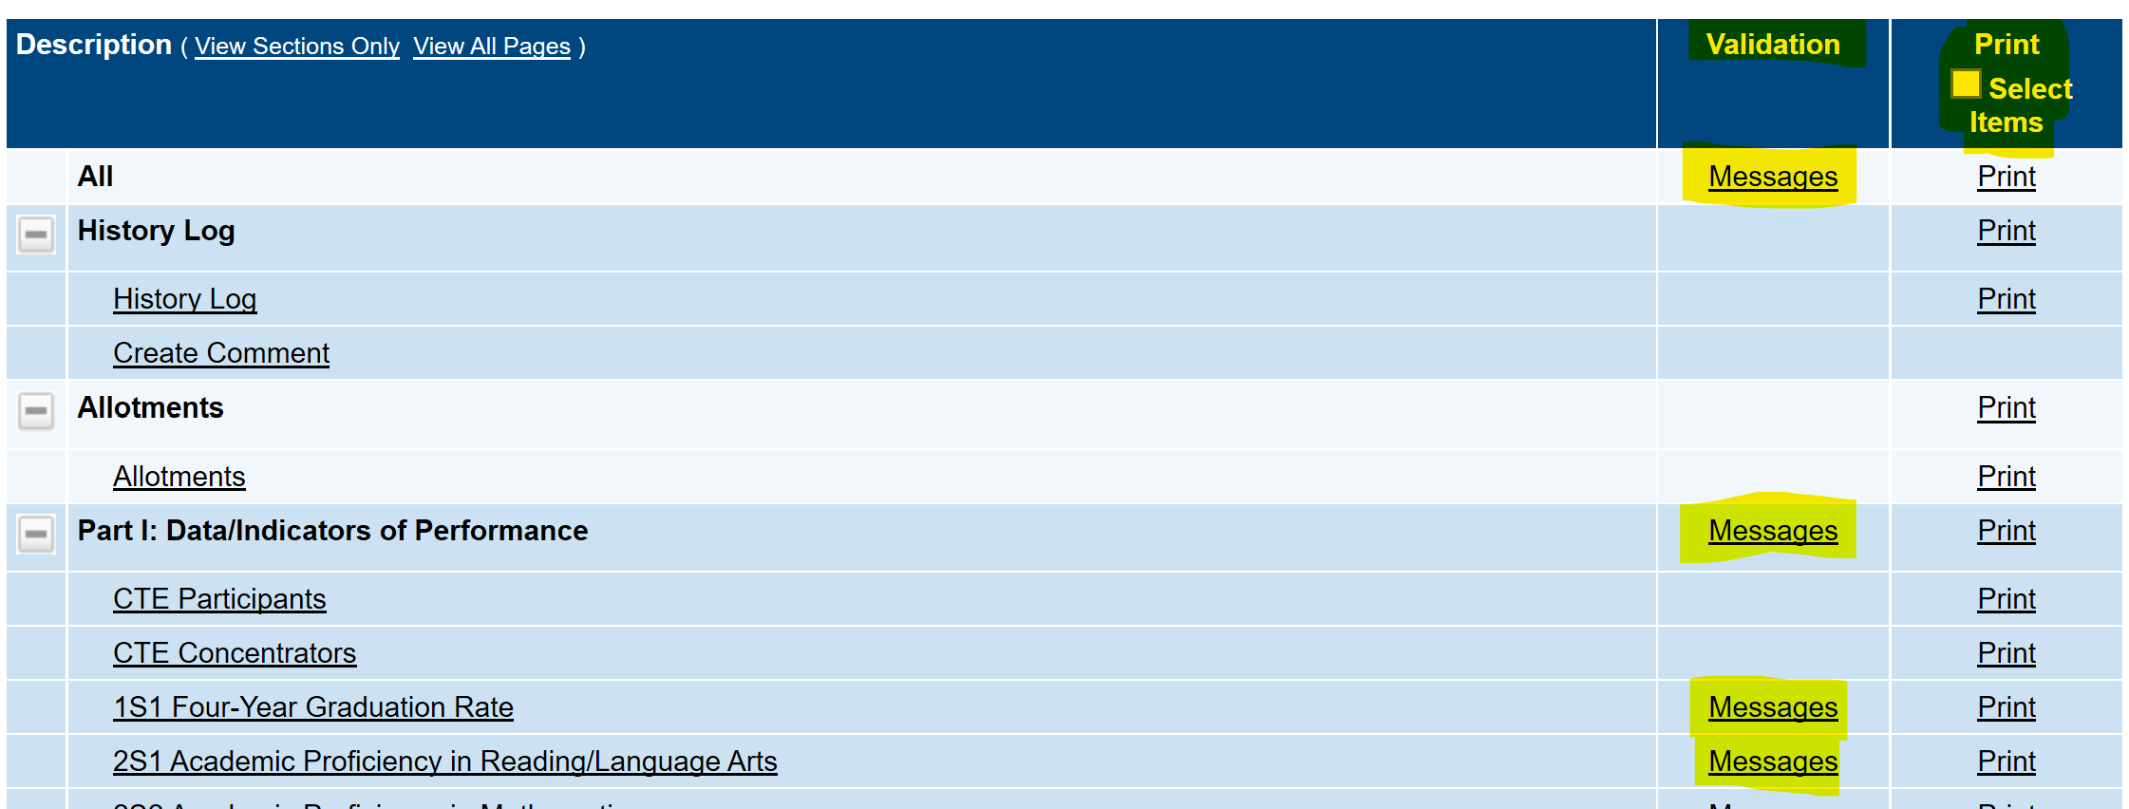

***CHANGE STATUS TO DRAFT COMPLETED***

***by clicking on the “Draft Completed”***

# CTE Local Application Checklist/NCDPI Feedback

The NCDPI Feedback textboxes and the checklist are a means of communication between DPI and PSUs regarding the allowability and allocability of the items submitted in the funding application. Please follow the steps below to ensure that the funding application contains items that are in compliance with program requirements.

* After the PSU submits the application, DPI will review each section of the application and provide feedback in the NCDPI Feedback textbox. The will also mark each section in the CTE Local Application Checklist as “OK”, “Not Applicable”, or “Attention Needed.” If the application contains no items that are marked as “Attention Needed”, the application will be approved.
* If the application contains items that are marked as “Attention Needed”, the application will be returned to the PSU with a status of Not Approved. The PSU will review the NCDPI Feedback textbox to review items that may need to be updated. The checklist will also identify areas to update by being marked “Attention Needed”. The PSU should make the necessary changes to those items. Only the checked items in the sections marked “Attention Needed” are to be corrected and/or explained. Each section marked “Attention Needed” will have notes in the NCDPI Feedback textbox in that section and DPI may also provide notes in the checklist to provide additional explanation. The PSU should check for NCDPI Feedback notes and additional comments.
* Once the PSU has made the necessary adjustments, the PSU will resubmit the application for approval. If DPI determines that the item has been appropriately revised, “Attention Needed” will be changed to “OK” by the DPI Reviewer. If the items needing attention have not been addressed, the application will be returned to the PSU with a status of Not Approved.
* Applications that contain no items that are marked Attention Needed will be approved.

# Additional Information

**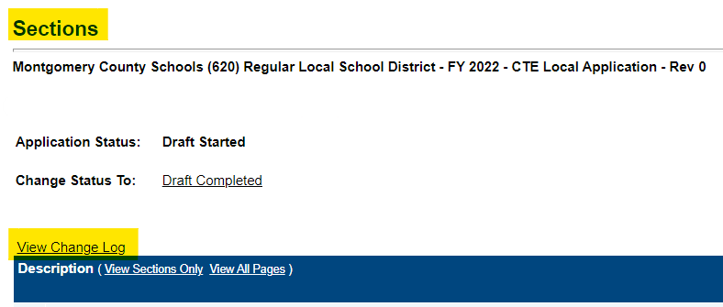*Change Log***: Utilize to see changes that have occurred within the original application or revision.

***Funding*** from the menu allows users to navigate to funding applications, sections, budget summary, last page visited and application supplements.

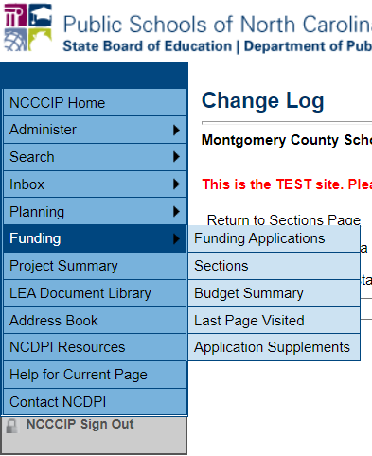

***Save and Go To*** is located at the top and bottom of each section and allows users to navigate to the next or previous page as well as to any section within application.

