CTE Local Application CLNA & Data/Indicator of Performance CTE Director Submission
Part I CLNA and Part II Data/Indicators of Performance due by close of business March 15, 2024.
Upon completion of Part I and Part II CTE Director will notify Regional Coordinator using CTE Local Application Comments and Email.
Select Create Comment
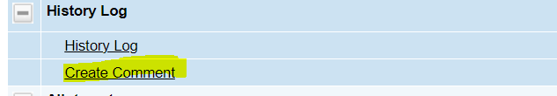

Enter comment:
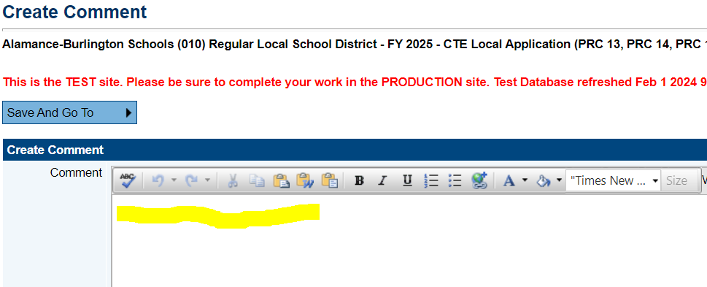

Example: Part I and Part II Complete 2/28/2024
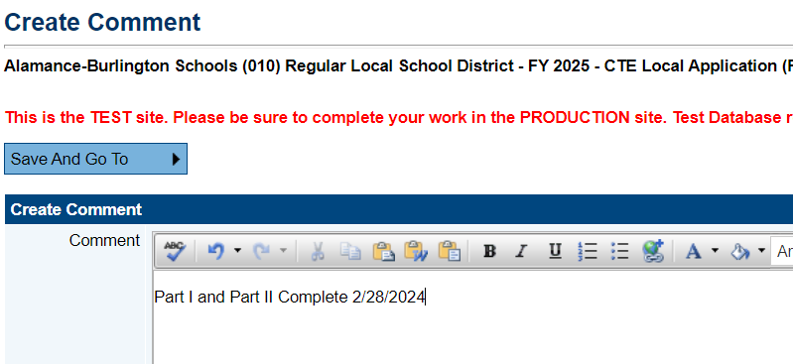

Select Send Email
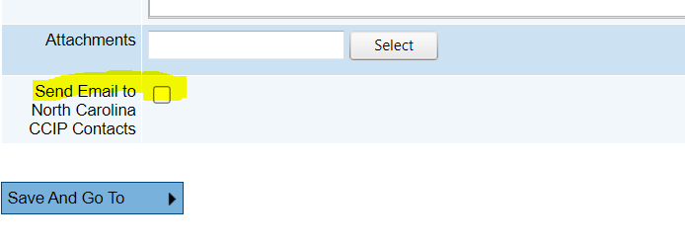
Select Regional Coordinator as Contact and “Add”
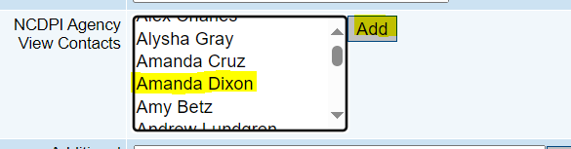

You will see the Regional Coordinator added at the bottom of the page.
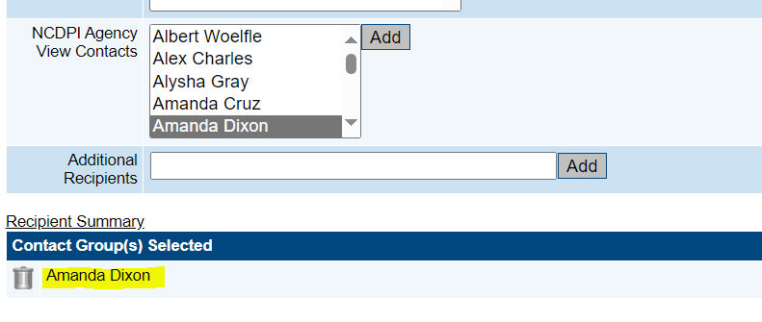
Select Save and Go To. This will save the comment.
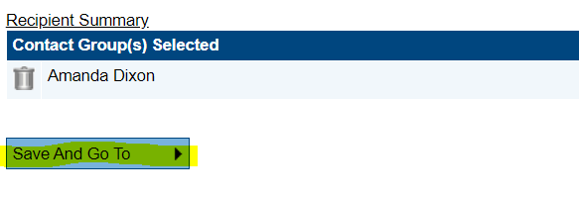
Confirm by viewing History Log
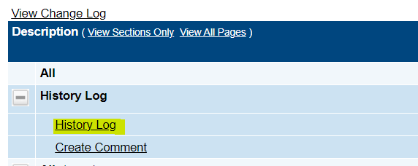

Comment is documented.
