**Special State Reserve Program Fund Reversion**

**Instructions:**

**Complete the form and obtain signatures.**

**Then upload a scanned copy into the Related Documents tab of the Risk Pool grant.**

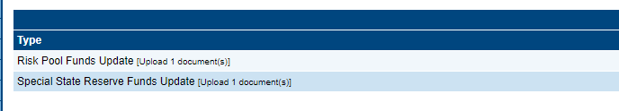

**Date:**

**PSU Name:**

**PSU Number:**

**Please complete the following table for all Special State Reserve funds that will not the expended during the 2024 – 2025 school year.**

|  |  |  |  |
| --- | --- | --- | --- |
| **Student ID#** | **Initial Allotment** | **Funds to be reverted** | **Reason for Reversion\*** |
|  |  |  |  |
|  |  |  |  |
|  |  |  |  |
|  |  |  |  |
|  |  |  |  |
|  |  |  |  |

**\*Sample of reasons for reversion:**

* **Enrolled but not attending full time**
* **Withdrawn from PSU**

**Signature: __________________________________ ___________________**

**EC Director/Coordinator Date**

**Signature: __________________________________ ___________________**

**Finance Officer Date**

**Signature: __________________________________ ___________________**

**Superintendent Date**