How to “Unhide” the Year 6 tabs on the MOE Spreadsheet
The MOE spreadsheet is a 10-year spreadsheet. Since there are so many tabs, only years 1 – 5 are currently visible. Below are the steps to unhide the remaining tabs.
- Right click between tab 19 and tab 38
- Click Unhide on the pop-up menu
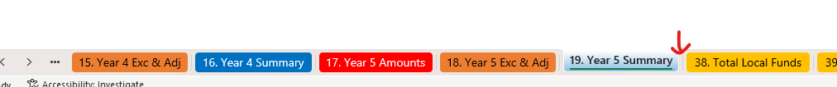

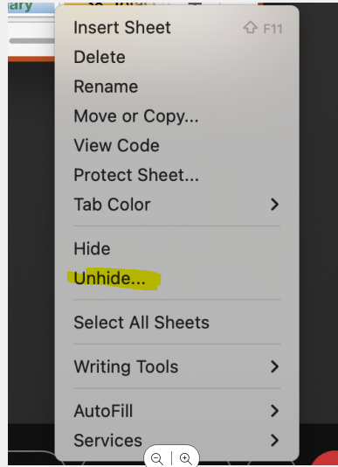

- The list of hidden tabs will pop up. You can select only the three Year 6 tabs or more.
Hold the control (ctrl) key while clicking on the tabs you want to unhide.
Then click OK.
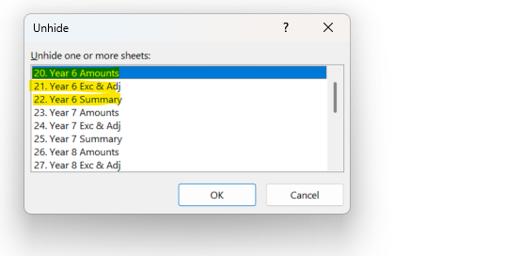

You will now see the tabs you selected.

